21BDS0340

Abhinav Dinesh Srivatsa

Programming for Data Science

Tableau Visualisation

All visualisation in the assignment uses the data from the following link:

<https://www.kaggle.com/datasets/meruvulikith/90000-cars-data-from-1970-to-2024>

The following in some metrics that compare the mean price of a car and mean mileage per car company. We can see that Mercedes, Audi and BMW have the highest prices. BMW, Audi and Vauxhall offer the best mean mileage.

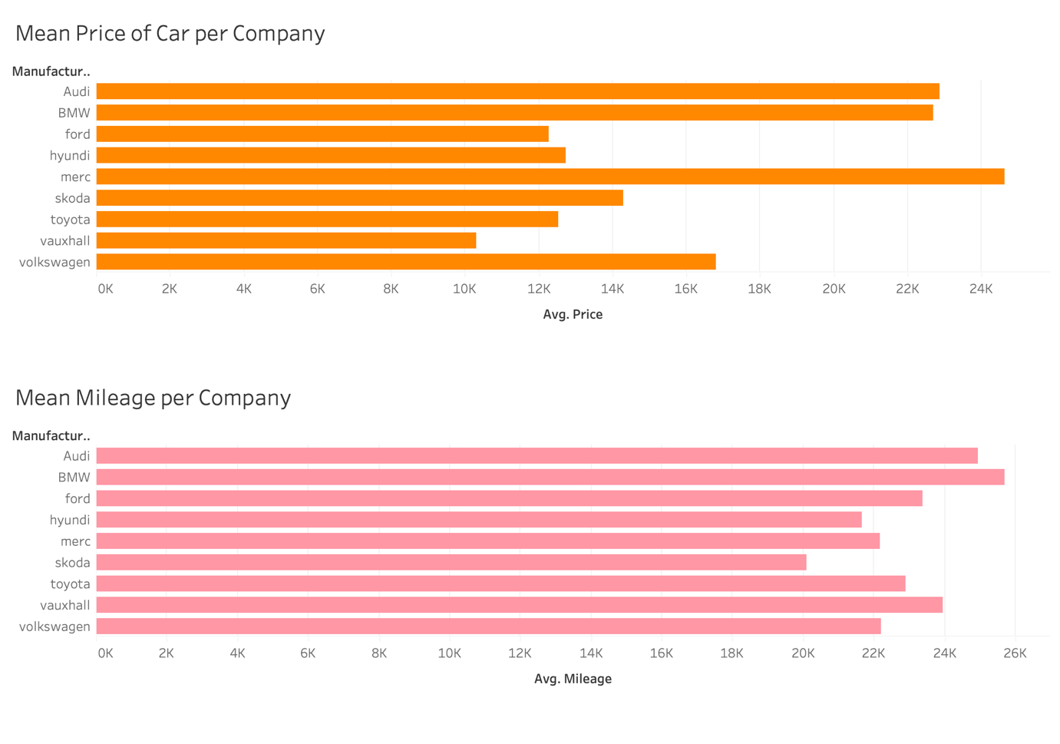

The next metric compares the mean mileage per price for each company. From the metrics, Vauxhall has the best mileage per price, followed by Ford and Toyota.

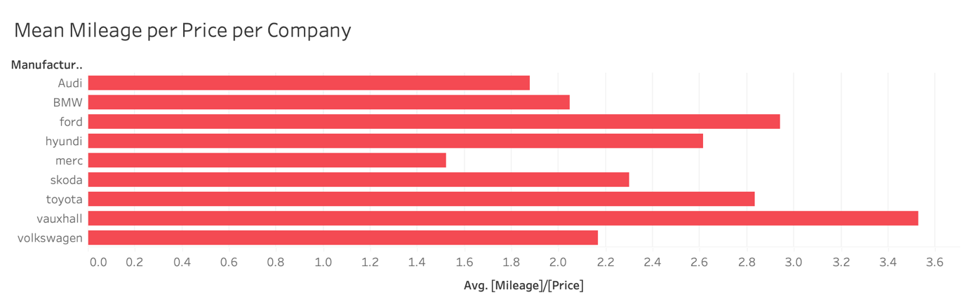

The following metric is the car prices per year. We can see an upward trend as prices increase of the years.

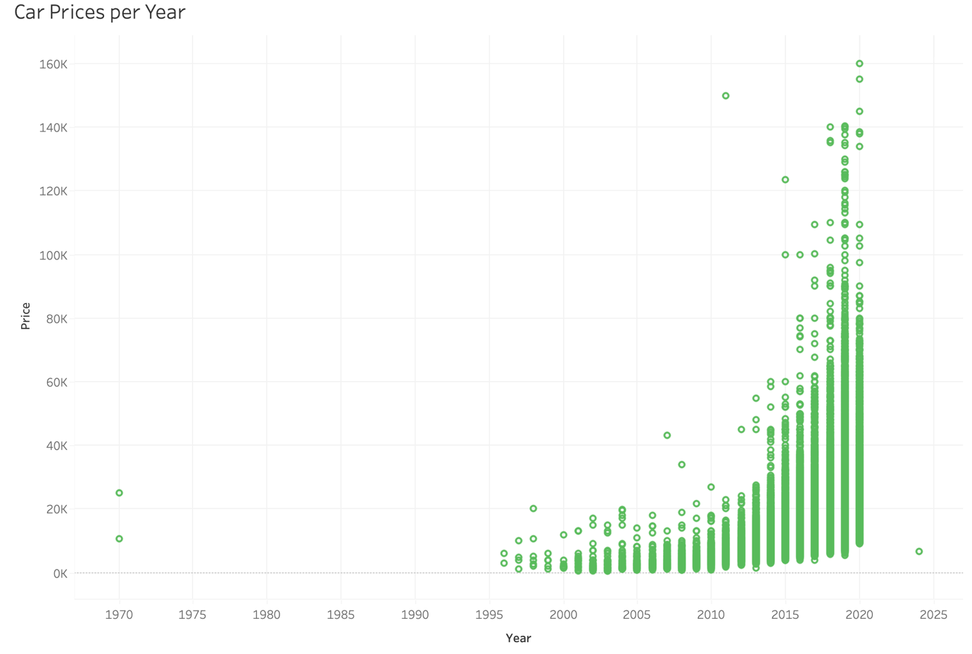

The following metric is the car prices based on the engine size, we can see that there is little to no correlation, as the median engine sizes constitute the highest prices.

